A dissertation submitted to the University of Greenwich
in partial fulfilment of the requirements for the Degree of
Master of Science
in
Big Data & Business Intelligence

Dijkstra’s Algorithm

for Google Maps

Name: Alvera
Student ID: 001420327

Supervisor: Dr. Margrita Razgon
Submission Date: 8 September 2025
Word count: 11,232

Dijkstra’s Algorithm for Google Maps

Computing & Mathematical Sciences, University of Greenwich, 30 Park Row, Greenwich, UK.
(Submitted 8 September 2025)

ABSTRACT
The invention, implementation, and optimization of Dijkstra's Algorithm for shortest path determination are examined in this dissertation, with an emphasis on how it is used in digital navigation systems like Google Maps. The necessity for precise and effective pathfinding techniques in transportation networks, where millions of users depend on routing systems on a regular basis for navigation, logistics, and decision-making, is what spurred this study. The correctness and optimality of Dijkstra's Algorithm, a fundamental graph-theoretic method, in positively weighted graphs are widely recognized. Optimizations are necessary for practical implementation because its naive implementation can be computationally costly for large-scale graphs.

The research emphasizes the role of the priority queue (min-heap) in improving the efficiency of the algorithm, reducing its time complexity from 𝑶(𝑽^{𝟐}) in a simple implementation to 𝑶((𝑽 +
𝑬)𝒍𝒐𝒈𝑽) , which is highly suitable for sparse road networks. The project includes a practical implementation in Python using NetworkX for graph modeling and Matplotlib for visualization, demonstrating shortest path computations on a simulated city map. Comparative analysis with alternative algorithms such as A*, Bellman-Ford, Bidirectional and Floyd-Warshall provides insights into trade-offs between performance, scalability, and applicability in different contexts.
The results show that even though heuristics, preprocessing methods, and real-time traffic data are frequently incorporated into contemporary navigation systems, Dijkstra's Algorithm—when optimized with a priority queue—remains a potent, dependable, and educationally relevant tool. The project demonstrates its applicability in educating, prototyping, and simulating real-world routing issues in addition to its theoretical significance. In the end, this dissertation confirms Dijkstra's Algorithm's lasting significance in algorithmic research and emphasizes its usefulness as a precursor to more sophisticated pathfinding strategies in modern navigation systems.

Keywords: graph algorithms, Dijkstra’s Algorithm, NetworkX, Matplotlib

PREFACE
The research and development efforts for the MSc in Big Data and Business Intelligence at the University of Greenwich have culminated in this dissertation, using a focus on its application to navigation systems like Google Maps, the project focuses on designing, implementing, and evaluating Dijkstra's Algorithm optimized using a priority queue (min heap).

Deep interest in algorithmic problem-solving and its applicability to common technology served as the driving force behind this effort. Because they facilitate effective travel, logistics, and decision-making, navigation aids have become an essential component of modern life. Complex graph algorithms underlie these systems, and in this paper, I have attempted to investigate one of the most fundamental methods for shortest-path computing.

I have blended theoretical research with real-world application throughout this undertaking. In addition to illustrating the workings of Dijkstra's Algorithm, I have also highlighted its educational and practical utility by modeling simplified road networks, putting the algorithm into practice in Python, and using NetworkX and Matplotlib to visualize the results. Its advantages and disadvantages were further supported by testing and evaluation in many contexts, particularly when compared to other algorithms like A* and Bellman-Ford.

In addition to improving my knowledge of graph theory, algorithm optimization, and data visualization, this work has given me the chance to hone my technical writing, project management, and critical thinking abilities. In addition to advancing my academic career, I genuinely hope that this project will be a resource for anyone else curious about the intriguing realm of graph algorithms and their practical uses.

ACKNOWLEDGEMENTS
For the tremendous advice, continuous support, and enlightening feedback during this dissertation, I would like to sincerely thank my supervisor, Dr. Margarita Razgon. Her support and knowledge have greatly influenced the direction of this effort.

For providing a stimulating academic atmosphere and the tools required for the effective completion of this project, I am also grateful to the faculty and staff of the University of Greenwich, School of Computing and Mathematical Sciences.
My family and friends deserve a special thanks for their consistent encouragement, tolerance, and support during this academic journey. Their confidence in me has always given me courage.

Finally, I acknowledge the authors, researchers, and open-source communities whose contributions to the fields of algorithms, graph theory, and data science have laid the foundation for this project.

Table of Contents

ABSTRACT 2
PREFACE 3
ACKNOWLEDGEMENTS 4
List of Figures 8
List of Tables 9
Chapter 1: Introduction 10
  - Overview 10
  - Methodology 10
    - Research Approach 11
    - Methodological Justification 13
  - Resources 13
    - Hardware 13
    - Software 13
    - Data: 14
    - External Resources 14
  - Critical success factors 14
Chapter 2: Litrature Review 14
  - Theoretical Foundations of Dijkstra’s Algorithm 15
  - Pseudocode for Dijkstra’s Algorithm 15
  - Applications in Navigation and Real-World Routing 25
  - Comparative Perspective: Alternatives to Dijkstra 26
    - Dijkstra’s Algorithm (Baseline) 26
    - A* (A-Star) Algorithm 26
    - Bellman-Ford Algorithm 27
    - Floyd-Warshall Algorithm 28
    - Bidirectional Dijkstra 28
    - Johnson’s Algorithm 29
  - Dijkstra’s Algorithm: Pros & Cons 31
Chapter 3: Analysis of the system 32
  - Legal Considerations 32
    - Copyright and Licensing 32
    - Data Protection and Privacy (DPA/GDPR) 32
    - Liability and Responsibility 33
    - Cybersecurity and Misuse of Data 33
    - Geopolitical and Export Control Concerns 33
  - Ethical Considerations 33
    - Accuracy and Potential Misuse 33
    - Bias and Fairness 34
    - Accessibility 34
  - Social Considerations 34
    - Public Understanding and Educational Value 34
  - Summary 35
Chapter 4: Optimization Techniques for Scalable Pathfinding 36
  - Introduction 36
  - The Role of the Priority Queue 36
  - Performance Improvement 36
  - Relevance to Google Maps and Large-Scale Routing 37
  - Limitations and Considerations 37
  - Summary 38
Chapter 5: System Design 39
  - Introduction 39
  - Design Objectives 39
  - System Architecture 39
    - Input Layer 39
    - Graph Construction Layer 39
    - Algorithmic Layer 39
    - Visualization Layer 40
    - Output Layer 40
  - Workflow of the System 40
  - Data Flow Design 41
  - Design Considerations 42
    - Efficiency 42
    - Scalability 42
    - Robustness 42
    - Usability 42
    - Educational Orientation 42
  - Advantages of the System Design 42
  - Summary 42
Chapter 6: Testing 44
  - White Box Testing 44
    - Definition and Approach 44
    - Code Segment Under Test 44
    - White Box Test Cases 45
  - Black Box Testing 45
    - Definition and Approach 45
    - Test Cases and Results 45
    - Observations 46
  - Comparative Insights 46
  - Summary 46
Chapter 7: Results and Analysis 47
  - Experimental Setup 47
  - Example Path Queries 47
  - Visual Output Analysis 52
  - Performance Evaluation 52
    - Execution Time 52
    - Accuracy 52
    - Robustness 52
  - Comparative Analysis 52
  - Discussion of Results 53
  - Summary 53
Chapter 8: Conclusions 54
  - Overview 54
  - Summary 54
  - Findings and Recommendations 54
  - Future Improvements 54
  - Personal Evaluation 55
REFERENCES 56
APPENDIX 57
Testing example 1 57
Testing Example 2: 58
Delhi.csv 59

List of Figures

Figure 1 Gantt Chart for project planning 13
Figure 2 Example 1 Graph 17
Figure 3 Example 1 Iteration 1 18
Figure 4 Example 1 Iteration 2 19
Figure 5 Example 1 Iteration 3 20
Figure 6 Example 1 Iteration 4 20
Figure 7 Example 2 Graph 22
Figure 8 Example 2 Iteration 1 22
Figure 9 Example 2 Iteration 2 23
Figure 10 Example 2 Iteration 3 23
Figure 11 Example 2 Iteration 4 24
Figure 12 Example 2 Iteration 7 25
Figure 13 Flow Chart 41
Figure 14 Djkstra code screenshot 44
Figure 15 Testcase 1 48
Figure 16 Testcase 2 49
Figure 17 Testcase 3 50
Figure 18 Testcase 4 50
Figure 19 Screenshot new node "XYZ" added in csv file 51
Figure 20 Testcase 4 51

List of Tables
Table 1 Critical success factors 14
Table 2 List of the abbreviations used in pseudocode 15
Table 3 Comparison between all searching algorithms 30
Table 4 White Box Test Cases 45
Table 5 Black Box Test Cases 46
Table 6 Execution Time 52

Chapter 1: Introduction
In real-world networks like social media platforms, communication systems, and roadmaps, graph algorithms are essential for resolving computational issues involving linked data structures. Dijkstra's Algorithm, which is frequently used to determine the shortest path in weighted graphs, is among the most significant algorithms in this field. With a particular focus on Python-based simulation and visualization, as suggested in the present MSc project, this literature study attempts to explore the concepts, applications, and implementations of Dijkstra's Algorithm in the context of digital navigation systems. It places the method in the context of contemporary computing environments by referencing basic works, useful tutorials, and comparative studies.

Overview

The goal of this project is to use Dijkstra's Algorithm to develop and implement a Python-based application that simulates a simplified version of a navigation system, similar to Google Maps. Dijkstra's approach, one of the most popular shortest-path algorithms, is a fundamental component of many real-world routing technologies, such as urban traffic planning systems and GPS navigation aids like Google Maps.

This project's main goal is to simulate a country's or city's simplified road system. The graph uses the Delhi map, with each road serving as a weighted edge (distance) and each location as a vertex. The quickest route between two user-specified places will then be determined by the algorithm.

The project will develop a user-friendly application that not only determines the shortest path between two points but also clearly displays the complete route on a graph by leveraging Matplotlib for visualization and Python's NetworkX package for graph modification. The application will return and show the best path when users enter the origin and destination nodes.

This project will strengthen understanding of graph algorithms, enhance Python programming skills, and provide practical experience in visualizing data structures. It reflects real-world applications in GPS navigation, network routing, and urban planning, demonstrating the practical relevance of algorithmic thinking.

Key outcomes of this project include:
- Implement Dijkstra’s Algorithm in Python for shortest path computation.
- Simulate a simplified map as a weighted graph structure.
- Provide clear visualizations of route paths and the underlying graph.
- Build an interactive user interface for path-finding queries.

This project will serve as both a practical tool and an educational model to explore how graph algorithms support everyday technologies such as Google Maps.
By the end of the project, the application will serve as both a practical tool and an educational resource which will illustrating how algorithmic thinking and data structures solve the daily problems in navigation, logistics, and network optimization.

Methodology

The technique offers a well-organized road map for accomplishing the project's research goals. It describes the procedures used to develop, put into practice, and assess Dijkstra's Algorithm with

a priority queue, guaranteeing that the project is both practically sound and academically rigorous. The study methodology, data gathering, algorithm creation, visualization, and testing procedures are all covered in this chapter, along with the rationale behind each methodological decision.

Research Approach

      - Objective 1: To understand the principles of Dijkstra’s Algorithm and its real-world applications in navigation systems.

Studying the fundamentals of graph theory and shortest path algorithms is the initial goal in order to provide a strong theoretical basis for the project. This entails a thorough analysis of scholarly works that describe the mathematical foundation, effectiveness, and workings of Dijkstra's Algorithm. This goal goes beyond the theoretical investigation to include an analysis of the algorithm's practical implementations in Google Maps, GPS-based navigation systems, and transportation logistics.

To emphasize the special advantages and disadvantages of Dijkstra's method, a comparative viewpoint will also be used to assess other shortest path algorithms like A* and Bellman-Ford.
This comparative study will not only strengthen theoretical understanding but also justify the
selection of Dijkstra’s Algorithm as the computational core for this project.

Deliverables:
        - A structured literature review section in the dissertation report.
        - A summary table comparing shortest path algorithms in terms of complexity, efficiency, and suitability for navigation systems.

Objective 2: To model a simplified road network as a graph using NetworkX.

The second goal is to create a graph-based representation of a simplified road network, which will be used as the algorithm's testing environment. Cities or crossroads will be represented by nodes in this model, and highways or roads by edges which indicates the total distance between each of the nodes connected..
This graph structure will be made using Python's NetworkX package, which guarantees its scalability and flexibility. After the network has been built, it will be visualized using Matplotlib to confirm node connectivity and edge weights. When shortest pathways are calculated and shown in later phases, this visual representation will also act as a baseline.

Deliverables:
        - A Python-based graph representation of a simplified road network.
        - An initial network visualization output for validation and reporting.

Objective 3: To design and implement Dijkstra’s Algorithm in Python using NetworkX.

The final goal is to calculate the shortest pathways within the modelled graph by algorithmically implementing Dijkstra's Algorithm. To do this, a program that can dynamically take user input for origin and destination nodes must be designed. The algorithm will then be used to determine the best path and the distance that goes with it.

Python’s heapq module will be used to optimize the algorithm with a priority queue (min heap), thereby improving efficiency. The implementation will be tested against different graph scenarios to ensure accuracy and performance.

Deliverables:

        - A Python script implementing Dijkstra’s Algorithm for shortest path computation.
        - Example outputs generated from user-defined queries (e.g., source and target locations).

Objective 4: To visualize shortest paths on the graph.

The fourth goal is to improve the project's interpretability and usability by generating a graphical representation of calculated shortest pathways. To differentiate the shortest path from other edges, the system will use various colors and line styles to emphasize the best path found by the algorithm right on the graph.

Further, annotations will be added to indicate distances, labels, and key nodes, thereby providing a clear and informative output. This visual demonstration will be particularly valuable in the academic and educational context, as it allows learners to intuitively understand how the algorithm operates in practice.

Deliverables:
        - Graphical visualization of computed shortest paths.
        - Annotated graphs to be included in the report and appendix.

Objective 5: To test and evaluate the system using various scenarios.

The assessment and validation of the deployed system are covered in the fifth goal. To cover a range of scenarios, a number of test cases will be developed. These will include graphs with variable edge weights, path complexities, and probable anomalies such detached nodes or cycles. To evaluate the effectiveness and correctness of the system, performance measures including execution time and path selection accuracy will be examined. Additionally, edge cases will be methodically recorded to show how reliable the implementation is.

Deliverables:
        - Detailed test case documentation.
        - An evaluation summary presented in tabular form, accompanied by a critical discussion of results.

Objective 6: To create a comprehensive project plan and documentation.

The necessity of project management and documentation is emphasized in the final goal. Research, algorithm creation, testing, visualization, and reporting are just a few of the phases that will be broken down into activities in an organized project plan. A Gantt chart will be used to manage timetables, track milestones, and keep an eye on progress as part of this plan.
Furthermore, technical documentation that describes the design, code structure, and dependencies as well as user documentation that explains how to run and interpret the program will be compiled. This guarantees the project's transparency, reproducibility, and extensibility for researchers in the future.

Deliverables:
        - Gantt chart and project task breakdown.
        - Complete user and technical documentation included in the dissertation report.

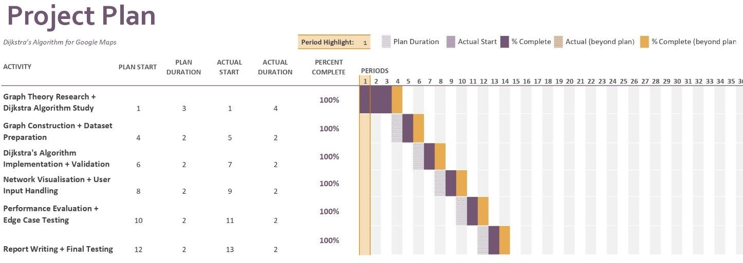
Figure 1 Gantt Chart for project planning

Methodological Justification

The methodology was specifically developed to strike a balance between practical implementation and scholarly depth.
- By placing the study within the context of previous research, the literature review guaranteed a solid basis.
- The dataset-driven methodology maintained the system's tractability while enabling real- world applicability.
- For sparse graphs, such as transportation networks, the priority queue optimization was chosen because it achieves the ideal balance between simplicity and efficiency.
- Both external dependability and internal accuracy were guaranteed by the dual testing approach (white and black box).
- The project's instructional value was increased by using visualization as a learning tool in addition to an output method.

Resources

Hardware:

- Laptop with 8GB–16GB RAM for development and testing.
- Access to university lab machines or cloud environments (optional) for handling large graphs or advanced visualization.

Software:
- Python (3.x)
- Jupyter Notebook or an IDE like VS Code/PyCharm
- NetworkX (for graph creation and algorithm support)
- Matplotlib / PyPlot (for graph visualization)

Data:
- Synthetic or manually constructed country/location dataset CSV)

External Resources:
- Documentation from NetworkX and Matplotlib
- Academic sources like CLRS (Introduction to Algorithms) for theoretical reference
- Open-source examples or tutorials of shortest path algorithms

Critical success factors

Risk | Impact | Likelihood | Mitigation Strategy
Misimplementation of Dijkstra’s algorithm | High | Medium | Thoroughly test the algorithm with known input/output; use pseudocode and step- by-step tracing.  Compare with networkx.dijkstra_path() as a benchmark.
Difficulty in creating a realistic graph | Medium | High | Start with small, hardcoded graphs for testing.
Bugs or software environment issues | Medium | Medium | Use virtual environments to manage dependencies. Back up code regularly and use version control (e.g., GitHub).
Poor visual output or accessibility concerns | Low | Low | Follow visualization best practices and test output on different devices. Use accessibility-friendly  colour schemes and fonts.
Time management issues | High | Medium | Create a detailed schedule (Gantt chart). Allocate buffer time for debugging and unexpected delays.  Track progress weekly.
Table 1 Critical success factors

Chapter 2: Litrature Review

Theoretical Foundations of Dijkstra’s Algorithm

Dijkstra's method is a greedy method that effectively resolves the single-source shortest path issue in graphs with non-negative edge weights, according to Cormen et al. (2009). Until all reachable nodes have been analyzed, the algorithm iteratively chooses the node with the minimum tentative distance, updates nearby distances, and continues. This guarantees completeness and optimality.

As described by Cormen et al. (2009) in Introduction to Algorithms, the algorithm’s time complexity is 𝑂((𝑉 + 𝐸)𝑙𝑜𝑔 𝑉) when implemented with a min-priority queue and adjacency list, making it suitable for sparse graphs such as road networks. This theoretical robustness makes it a suitable candidate for navigation-based simulations.

The algorithm's significance is further emphasized by Sedgewick and Wayne (2011), who highlight its effectiveness and predictability. They point out that Dijkstra's Algorithm is still useful for sizable, sparse graphs, such those used to simulate transportation networks, particularly when applied to effective data structures like binary heaps.

The theoretical basis for employing Dijkstra's Algorithm as the computational powerhouse behind routing systems such as Google Maps, where accuracy and assured optimality are crucial, is presented in these works.

Pseudocode for Dijkstra’s Algorithm

Explanation of Terms used in pseudo code:

Symbol | Meaning
G | Graph with vertices V and edges E
s | Source vertex
t | Target (destination) vertex
w(u, v) | Weight of the edge from u to v
v.d | Current shortest-path estimate for vertex v
v.π | Predecessor of vertex v on the shortest path
heap | Priority queue (min-heap), ordered by path  cost
visited | Set of nodes for which the shortest path is  finalized

Table 2 List of the abbreviations used in pseudocode
- Steps of the pseudo code:

- for each vertex v in G.V do
- v.d ← ∞ // Initialize distance from source
- v.π ← NIL // Initialize predecessor

- s.d ← 0 // Distance to source is zero
- visited ← ∅ // Set of visited nodes

- heap ← [(0, s, [])] // Min-heap storing (distance, vertex, path)

- while heap is not empty do
- (current_cost, u, path_so_far) ← EXTRACT-MIN(heap) //Pop the node with the smallest cost so far

- if u ∈ visited then
- continue // Skip if already visited

- visited ← visited ∪ {u} // Mark node as visited
- path_so_far ← path_so_far + [u] // Add the current node to the path

- if u = t then //if reaches the destination
- return (path_so_far, current_cost) // Destination reached

- for each neighbour v of u do //Explore the neighbours od current node
- if v ∉ visited then
- RELAX(u, v, w)
- heap.INSERT((current_cost + w(u, v), v, path_so_far)) //Push the traced nodes with cost and path in heap

- return (NIL, ∞) // No path found

  - Example of how this pseudo code will run:

Example 1:

Input:

Graph: {
‘A’: [(‘B’, 2), (‘C’, 1)],
‘B’: [(‘A’, 2), ('D', 3), (‘E’,1)],
‘C’: [(‘A’, 1), (‘E’, 4)],
‘D’: [(‘B’, 3), (‘E’, 1)],
‘E’: [(‘C’, 4), (‘B’,1) (‘D’, 1)]
}
2
3
A
B
D
1
1
1
C
E
4

Figure 2 Example 1 Graph

Step 1:
Initialize a priority queue (min_heap) with tuple (0, 'A', [])
- Initial state of heap: [(0, 'A', [])] (Property of heap is the least number comes on top when a value is pushed or popped)
- Meaning: cost = 0, current node = A, path = []

Step 2:
Initialize an empty set visitedy
- Initial visited set: {}

Iteration 1

Step Pop A (0, A, []) from heap Mark A as visited
Add neighbors:

→ B: cost = 0 + 2 = 2

→ C: cost = 0 + 1 = 1

Min_heap = [(1, C, [A]), (2, B, [A])]
2
2
3
A
B
D
1
1
1
C
E
4

1

Figure 3 Example 1 Iteration 1

Iteration 2

Step

Pop C (1, C, [A])

Mark C as visited Add neighbor:
→ E: cost = 1 + 4 = 5

Min_heap = [(2, B, [A]), (5, E, [A, C])]
2
2
3
A
B
D
1
1
1
C
E
4

1
5
Figure 4 Example 1 Iteration 2

Iteration 3

Step

Pop B (2, B, [A])

Mark B as visited Add neighbors:
→ D: cost = 2 + 3 = 5

→ E: cost = 2 + 1 =3

Min_heap = [(3, E, [A, B]), (5, D, [A, B]), (5, E, [A, C])]

2
5
2 3
A
B
D
1
1
1
C
E
4
1
5
3

Figure 5 Example 1 Iteration 3

Iteration 4 Step
Pop D (5, D, [A, B])

Mark D as visited Add neighbor:
→ E: cost = 5 + 1 = 6

Min_heap = [(3, E, [A, B]), (5, E, [A, C]), (6, E, [A, B, D])]
2
5
2 3
A
B
D
1
1
1
C
E
4

1
5
3
6
Figure 6 Example 1 Iteration 4

Iteration 5

Step

Pop E (3, E, [A, B])

Mark E as visited (goal reached) Return: path = A → B → E Total Distance = 3 km

Explanation:

The execution of Dijkstra’s Algorithm using a priority queue begins by initializing the heap with the source node A at cost 0 and an empty path. At each step, the node with the smallest tentative distance is extracted from the heap, marked as visited, and its neighbors are evaluated. From A, paths to B (cost 2) and C (cost 1) are added, after which C is explored and contributes a potential path to E (cost 5). Expanding B introduces two new candidates: D at cost 5 and E at cost 3.
When E is finally extracted from the heap with the lowest cost, the algorithm terminates, returning the shortest path A → B → E with a total distance of 3 km. This process highlights the efficiency of the min heap, which ensures that the algorithm always expands the most promising node first, leading to an optimal solution.
Example 2: Graph: edges = [
("0", "1", 7),
("0", "2", 9),
("0", "5", 14),
("1", "2", 10),
("1", "3", 15),
("2", "3", 11),
("2", "5", 2),
("3", "4", 6),
("4", "5", 9)
]

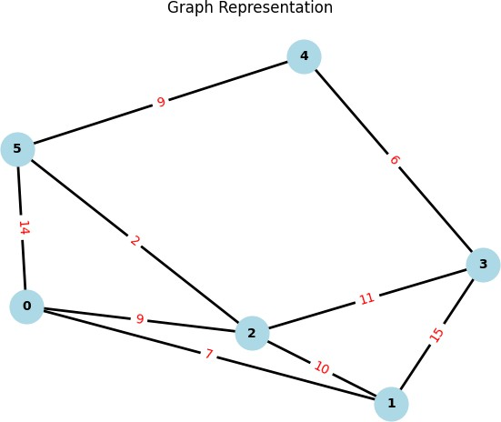

Figure 7 Example 2 Graph

Iteration 1 Step
Pop 0 (0, 0, [])
Mark 0 as visited Add neighbor:
→ 5: cost = 0 + 14 = 14
→ 2: cost = 0 + 9 = 9
→ 1: cost = 0 + 7 = 7
Min_heap = [(7, 1, [0]), (9, 2, [0]), (15, 5, [0])]

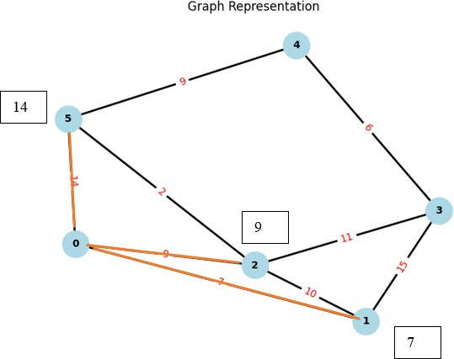
Figure 8 Example 2 Iteration 1

Iteration 2 Step
Pop 1 (7, 1, [0])
Mark 1 as visited
Add neighbors (unvisited):
- → 2: cost = 7 + 10 = 17
- → 3: cost = 7 + 15 = 22
Min_heap = [(9, 2, [0]), (14, 5, [0]), (17, 2, [0, 1]), (22, 3, [0, 1])]
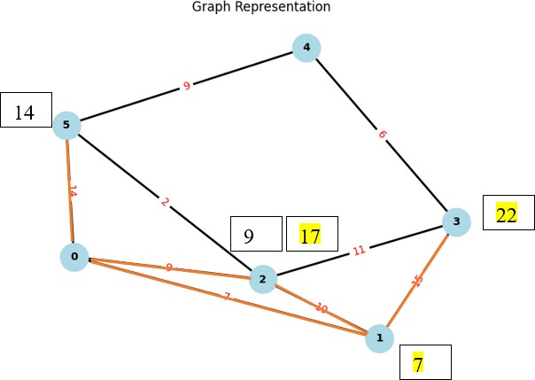

Figure 9 Example 2 Iteration 2

Iteration 3 Step
Pop 2 (9, 2, [0])
Mark 2 as visited
Add neighbors (unvisited):
- → 3: cost = 9 + 11 = 20
- → 5: cost = 9 + 2 = 11
Min_heap = [(11, 5, [0, 2]), (14, 5, [0]), (17, 2, [0, 1]), (22, 3, [0, 1]), (20, 3, [0, 2])]
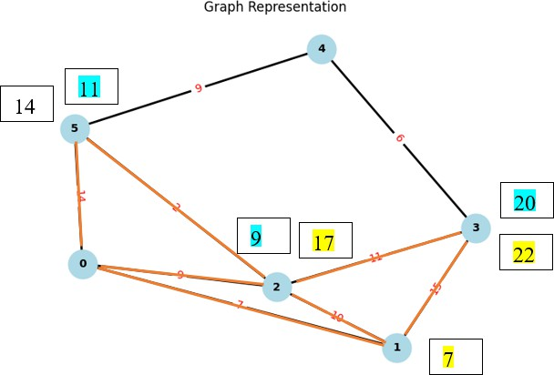
Figure 10 Example 2 Iteration 3

Iteration 4 Step
Pop 5 (11, 5, [0, 2])
Mark 5 as visited
Add neighbors (unvisited):
- → 4: cost = 11 + 9 = 20
Min_heap = [(14, 5, [0]), (17, 2, [0, 1]), (20, 3, [0, 2]), (22, 3, [0, 1]), (20, 4, [0, 2, 5])]

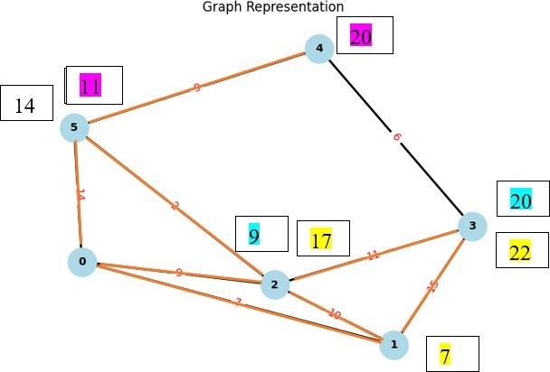
Figure 11 Example 2 Iteration 4

Iteration 5 Step
Pop 5 (14, 5, [0])

already visited → skip
Min_heap = [(17, 2, [0, 1]), (20, 3, [0, 2]), (20, 4, [0, 2, 5]), (22, 3, [0, 1])]

Iteration 6 Step
Pop 2 (17, 2, [0, 1])

2 already visited → skip
Min_heap = [(20, 3, [0, 2]), (20, 4, [0, 2, 5]), (22, 3, [0, 1])]

Iteration 7 Step
Pop 3 (20, 3, [0, 2])
Mark 3 as visited
Add neighbors (unvisited):
- → 4: cost = 20 + 6 = 26
Min_heap = [(20, 4, [0, 2, 5]), (22, 3, [0, 1]), (26, 4, [0, 2, 3])]


20
26
Figure 12 Example 2 Iteration 7

Iteration 8 Step
Pop 4 (20, 4, [0, 2, 5])
Mark 4 as visited → destination reached Min_heap = [(22, 3, [0, 1]), (26, 4, [0, 2, 3])]

Result
Shortest path: 0 → 2 → 5 → 4
Total cost: 20

Applications in Navigation and Real-World Routing

Numerous routing applications, such as GPS, drone pathfinding, network routing, and urban mobility planning, rely on Dijkstra's Algorithm. According to FreeCodeCamp (2020), Dijkstra's Algorithm is still essential to comprehending how digital maps work, even though commercial services like Google Maps may employ more sophisticated techniques (such as A* for heuristic efficiency).

In the context of this MSc project, modelling a simplified map (e.g., Delhi) as a weighted graph offers a practical demonstration of the algorithm's power, especially in educational and low-scale simulation contexts where accuracy and clarity are prioritised over computational speed.

The ability to compute and visualise shortest paths is crucial not just for navigation, but also for logistics, communication networks, and robotics. Because of its dependability and simple logic, Dijkstra's Algorithm is still utilized in various fields and is a great option for teaching simulations.

Comparative Perspective: Alternatives to Dijkstra

From straightforward instructional examples to practical applications like Google Maps, network routing protocols, and logistics optimization, the shortest path algorithms form the foundation of contemporary routing and navigation systems. Although there are a number of techniques for shortest path issues, the graph topology, edge weights, and use case requirements greatly affect each algorithm's performance, applicability, and efficiency.

Five popular algorithms—Dijkstra's Algorithm, A* (A-star), Bellman-Ford, Floyd-Warshall, and Bidirectional Dijkstra—are thoroughly compared in this section. Their applicability for real-world navigation tasks, their strengths and drawbacks, their capacity to handle various edge circumstances, and their time and space complexity are the main points of comparison.

Dijkstra’s Algorithm (Baseline)
      - Core Idea: Greedy approach that expands the nearest unvisited vertex until the destination is reached.

Time Complexity:
        - 𝑂(𝑉²) for a simple array implementation.
        - 𝑂(𝐸 + 𝑉 log 𝑉) with a Fibonacci or binary heap.

Strengths:
        - Produces exact shortest paths reliably.
        - Particularly effective on sparse graphs, such as road networks, where the number of edges is significantly smaller than 𝑉².
        - Straightforward to implement and widely adopted in teaching and industry.

Weaknesses:
        - Cannot process graphs with negative edge weights, which may cause incorrect results.
        - For very large graphs (e.g., millions of nodes, as in Google Maps), additional optimizations or preprocessing techniques are needed.

Applications:
Often used in network routing, logistics planning, and navigation systems where edge weights (such as cost, time, and distance) are non-negative.

A* (A-Star) Algorithm

Peter Hart and Bertram Raphael of the Stanford Research Institute (now SRI International) first published the method in 1968. The A* Search algorithm, which has "brains" unlike other traversal methods, is one of the best and most used techniques for path-finding and graph traversals. Stated differently, it is an ingenious algorithm that distinguishes itself from other conventional algorithms. The next sections provide a detailed explanation of this fact.
      - Design: A* augments Dijkstra’s algorithm with a heuristic function ℎ(𝑛) that estimates the cost from node 𝑛 to the goal. It uses the formula:

𝑓(𝑛) = 𝑔(𝑛) + ℎ(𝑛)
where 𝑔(𝑛) is the cost from the start to node 𝑛 , and ℎ(𝑛)is the heuristic estimate to the goal.

Strengths:
        - Prioritizes nodes that are closer to the target using heuristic functions (such as Manhattan distance or Euclidean distance).
        - It is very effective for geographical navigation since it significantly shrinks the search space in spatial graphs.
        - If the heuristic is admissible, it yields the best results (never overestimates the distance).

Weaknesses:

        - Performance depends heavily on the quality of the heuristic. Poor heuristics reduce A*
to the performance of Dijkstra’s Algorithm.
        - Designing suitable heuristics is non-trivial for abstract graphs.

Use Cases:
        - Navigation systems.
        - Robotics path planning.
        - Game development.

Bellman-Ford Algorithm

The Bellman–Ford algorithm is used to determine the shortest paths between a single source vertex and each other vertex in a weighted digraph. It is more adaptable because it can handle graphs with some negative edge weights, but it is slower than Dijkstra's algorithm for the same problem. The technique was first created by Alfonso Shimbel in 1955, but it is now named for Richard Bellman and Lester Ford Jr., who published their own works in 1958 and 1956.
      - Design: Dynamic programming-based algorithm that relaxes all edges 𝑉 − 1 times.
      - Time Complexity: 𝑂(𝑉 ⋅ 𝐸)

Strengths:
        - Supports negative weights, where Dijkstra fails.
        - Can detect negative weight cycles, which is important for certain network and financial models.

Weaknesses:

        - Much slower than Dijkstra, especially for large graphs, making it unsuitable for real-time navigation.

        - Requires multiple relaxations over all edges, leading to higher computational overhead.

Use Cases:
        - Currency arbitrage.
        - Network routing with cost fluctuation.
        - Applications involving economic models with losses or penalties.

Floyd-Warshall Algorithm

The Floyd–Warshall algorithm, sometimes referred to as Floyd's algorithm, the Roy–Warshall algorithm, the Roy–Floyd algorithm, or the WFI algorithm, uses an all-pairs shortest path approach to determine the shortest paths between each pair of vertices in a weighted network. It uses dynamic programming to determine each pair's shortest paths. The array is two-dimensional.
      - Design: A dynamic programming algorithm that computes the shortest paths between all pairs of vertices.
      - Time Complexity: 𝑂(𝑉³)

Strengths:

        - Computes all-pairs shortest paths in one execution, unlike Dijkstra which is single-source.
        - Can handle both positive and negative weights (but not negative cycles).
        - Conceptually simple and elegant.

Weaknesses:

        - Extremely slow for large graphs, especially sparse transportation networks.
        - Requires 𝑂(𝑉²) memory, making it unsuitable for very large datasets.

Use Cases:
        - Precomputing distances in fully connected networks.
        - Transportation systems and inter-city route planning.

Bidirectional Dijkstra

Bidirectional search is a graph search method that finds the shortest path between an initial vertex and a goal vertex in a directed graph. In order to discover the path more quickly, it performs two searches simultaneously: one forward from the starting state and one backward from the target. It stops when they intersect.

      - Design: Runs two Dijkstra searches: one from the source and one from the target. The algorithm terminates when the frontiers meet.
      - Time Complexity: Approximately half of regular Dijkstra in practice.

Strengths:

        - Reduces the number of explored nodes by almost half, significantly improving efficiency.
        - Well-suited for real-time systems where both source and target are known in advance.

Weaknesses:
        - Requires the destination node in advance.
        - More complex to implement (dual priority queues).

Use Cases:
        - Real-time navigation in road networks.
        - Map-based applications with frequent queries.

Johnson’s Algorithm

Johnson's algorithm is a shortest path algorithm that solves the all pairs shortest path issue. The all pairs shortest path problem takes a graph with vertices and edges as input and finds the shortest path between each pair of vertices. The Floyd-Warshsall Algorithm and Johnson's algorithm are quite similar, however Floyd-Warshall performs better on dense graphs with many edges, whereas Johnson's method performs best on sparse graphs with few edges.
      - Design: computes all-pairs shortest routes in sparse graphs, including those with negative edge weights, by combining Bellman-Ford and Dijkstra.
        - Step 1: Use Bellman-Ford to re-weight all edges to eliminate negative weights.
        - Step 2: Run Dijkstra’s algorithm from each node.

Time Complexity:
        - 𝑂(𝑉 ⋅ 𝐸 + 𝑉² log 𝑉) with Fibonacci heap.

Strengths:
        - Efficient for sparse graphs.
        - Supports negative edge weights (no cycles).

Weaknesses:

        - More complex; requires re-weighting.
        - Less efficient for dense graphs compared to Floyd-Warshall.

Use Cases:
        - Sparse communication networks.
        - Distributed computing task optimisation.

Algorithm | Time Complexity | Space Complexity | Strengths | Weaknesses | Use Case (Example)
Dijkstra’s Algorithm (with Priority Queue) | 𝑶((𝑽  + 𝑬)𝒍𝒐𝒈 𝑽) | 𝑶(𝑽 + 𝑬) | Efficient for graphs with non- negative weights; scalable for sparse graphs; well-suited for transportation networks | Cannot handle negative edge weights; performance depends on heap implementation | Google Maps routing (road networks)
A* (A-star) | 𝑶((𝑽 +  𝑬)𝒍𝒐𝒈 𝑽) but faster in practice due to heuristic | O(V+E) | Incorporates heuristics (e.g., Euclidean distance) to guide search; faster for  spatial networks | Requires carefully chosen heuristic; performance degrades with  poor heuristics | GPS  navigation with estimated distances
Bellman- Ford | 𝑶(𝑽𝑬) | O(V+E) | Handles negative edge weights; simpler to implement | Much slower for large graphs; impractical for real-time routing | Financial models with negative weights
Floyd- Warshall | 𝑶(𝑽^{𝟑}) | 𝑶(𝑽^{𝟐}) | Computes all- pairs shortest paths; works with negative edges | Extremely slow for large graphs; very high memory usage | Small networks, academic teaching
Bidirectional Dijkstra | 𝑶((𝑽 +  𝑬)𝒍𝒐𝒈 𝑽) but roughly halved | 𝑶(𝑽 + 𝑬) | Faster in practice; searches from source and target simultaneously | More complex to implement; less effective if target is not known | Real-time road routing with known start and end points

Table 3 Comparison between all searching algorithms

Dijkstra’s Algorithm: Pros & Cons

Pros
Feature Explanation

Accurate & Optimal
For the graphs with non-negative weights, it always finds the shortest path.

Efficient with Heap
When implemented with a priority queue (min-heap), it performs well on sparse graphs.

Deterministic Gives consistent results without randomness.
Widely Used Ideal for real-world applications like GPS navigation, networks, and routing.

Cons
Limitation Explanation

No Negative Weights Fails if graph contains edges with negative weights.

Can Be Slow on Large Graphs
Especially without using a priority queue or for dense graphs.

Single-Source Only Not suitable for all-pairs shortest path unless used
repeatedly.

Ignores Directional Heuristics
Cannot estimate direction toward destination like A* does.

Sedgewick and Wayne (2011) highlight that while A* is more efficient for pathfinding in large- scale or dynamic graphs (like real-world maps), Dijkstra remains preferred for deterministic and fully known graphs due to its simplicity and predictability.

Therefore, for the scope and scale of this project, Dijkstra’s Algorithm provides the best balance
between accuracy, clarity, and computational efficiency.

Chapter 3: Analysis of the system

Legal, Social and Ethical Issues
It is crucial to take into account the wider legal, social, and ethical ramifications of creating a pathfinding system that mimics the functions of a navigation tool like Google Maps, even though this project does not directly involve human participants or the management of sensitive personal data.

Legal Considerations

Copyright and Licensing
Copyright and licensing requirements must be carefully considered when developing any system that mimics the features of a for-profit navigation platform, like Google Maps. This project has been built with a dedication to avoiding the use of proprietary content. In particular:

      - Data Sources: Every map and geographic dataset was either made by hand for simulation purposes, obtained from publicly accessible databases, or under an open-source license. No economically controlled or private datasets are used.
      - Software Libraries: NetworkX and Matplotlib are two examples of open-source libraries that are solely used in this project for graph representation and visualization, respectively. Permissive (BSD-style) licenses, which allow unrestricted academic and non-commercial use, are used to distribute both of these libraries.
      - Compliance Assurance: To guarantee adherence to pertinent intellectual property laws, the license for each dataset or tool was examined before integration. This stops accidental infringement of patented or copyrighted technology.

By adhering to these measures, the project ensures that it fully respects intellectual property rights and avoids potential legal challenges relating to copyright infringement.

Data Protection and Privacy (DPA/GDPR)

In the context of navigation systems, the handling of personal data—such as geolocation history, user profiles, and travel patterns—can create significant legal and ethical challenges under data protection frameworks like the UK Data Protection Act (DPA) and the General Data Protection Regulation (GDPR).

However, this project deliberately avoids such complexities by:

      - Personal Data Exclusion: No identifying or personal data is gathered, saved, or handled. The project only uses simulated datasets to function.
      - Outside legal Scope: Consequently, the project is not covered by the GDPR or DPA legal frameworks. However, because of their significance in the broader field of navigation technology, a fundamental understanding of these rules has been preserved.
      - Future-proofing: Adherence to GDPR principles, including informed permission, data minimization, storage limits, and user rights, will become crucial if this system's subsequent incarnations include actual user data.

This approach ensures that, while the current academic prototype is legally compliant, it also demonstrates an awareness of the regulatory challenges associated with scaling such systems into real-world applications.

Liability and Responsibility

In real-world navigation systems, accidents, delays, or monetary loss may arise from improper routes or system malfunctions. Such occurrences bring up issues of legal duty, such as who is at fault—the end user, the data source, or the program creator. Despite being an academic prototype, this project recognizes that liability frameworks must be built in real-world deployments to define who is responsible for system failures.

Cybersecurity and Misuse of Data

Malicious uses may be made of routing algorithms and navigation data. For instance, route manipulation could purposefully divert cars, and GPS spoofing assaults could bring people into dangerous areas. Although this research is not exposed to real-world cybersecurity threats, awareness of these vulnerabilities underscores the significance of secure algorithm design and data integrity verification in future systems.

Geopolitical and Export Control Concerns

The use of geographic data is not purely technical; it often intersects with political and legal sensitivities. For example, different countries dispute territorial boundaries, and maps can unintentionally reflect one political perspective over another. Similarly, advanced routing algorithms may fall under export control laws, as they can be applied in defense logistics and strategic planning. While this project avoids such issues by using simulated maps, acknowledgment of this dimension demonstrates broader legal awareness.

Ethical Considerations

Accuracy and Potential Misuse

Given that navigation systems directly influence user decisions in the real world, the ethical responsibility of accuracy is paramount. While this project is explicitly developed as an academic prototype:

- Clear disclaimers are included within the documentation and user interface to emphasize that the system is not suitable for real-world navigation.
- All data used is simulated and does not reflect real geographical conditions, thereby preventing unsafe reliance on the tool.

By proactively addressing these points, the project reduces the risk of misuse or over-reliance by end-users.

Bias and Fairness

Algorithms used in pathfinding systems may unintentionally reflect or reinforce biases if the underlying data is skewed toward specific regions or populations. To mitigate this risk:

- To ensure a fair geographic distribution, the simulated graph includes both urban and rural representations.
- Path calculations are designed to be free of discriminatory weighting, with all edges assigned neutral, logically consistent values.

This ensures that shortest path computations are conducted in a manner that avoids geographical or structural bias, thereby promoting fairness and inclusivity in educational demonstrations.

Accessibility

An ethically responsible academic project must consider accessibility to ensure inclusivity for users with different needs. In this project:

- To assist users with visual impairments, visual outputs make use of colourblind-friendly colours, high contrast themes, and unambiguous node labelling.
- Further improvements, including creating a graphical user interface (GUI), will follow accepted accessibility guidelines, such as the Web Content Accessibility Guidelines (WCAG). This would consist of:
  - Full keyboard navigation support,
  - Compatibility with screen readers, and
  - Design choices that prioritize usability for individuals with disabilities.
These considerations align with broader societal commitments to ensuring equitable access to digital technologies.

Social Considerations

Public Understanding and Educational Value

This project has been conceived not as a commercial product but as an academic and educational tool. Its social contribution lies in:

      - Demythologizing Algorithms: Giving students and the general public an understandable explanation of how pathfinding algorithms, like Dijkstra's, support popular apps like Google Maps.
      - Encouraging Computational Thinking: This helps users bridge the gap between abstract graph theory and real-world applications by helping them comprehend the workings of algorithmic decision-making.
      - Lessening Misconceptions: To prevent users from mistaking the prototype for a high- end navigation tool, explicit disclaimers are included.

Through these measures, the project contributes positively to public awareness of computational methods without overstating its real-world applicability.

Digital Divide

Globally, access to navigation technologies varies. Developing nations frequently lack the infrastructure necessary to take use of real-time, internet-based navigation systems, whereas developed nations do. Equity in access to technology breakthroughs is called into question by this digital gap. The project encourages inclusion and knowledge sharing across many contexts by utilizing open-source resources and placing a strong emphasis on educational accessibility.

Employment and Automation

In some fields, like delivery route planning or transportation management, automation of routing and logistics systems may lessen the need for human expertise. This study recognizes the wider societal ramifications of automation and highlights the necessity of retraining and upskilling workers in impacted industries, even while it has no direct effect on employment.

Cultural and Geopolitical Sensitivities

Maps may depict contentious areas or culturally sensitive sites, therefore they are not politically neutral. Despite using simulated maps, this study recognizes that navigation systems have an obligation to provide geographic data in a way that respects geopolitical and cultural settings.

Community Trust

The broad use of digital navigation systems depends on trust. Despite being academic, this effort helps to increase public confidence in algorithms because it is open, instructive, and explicitly marked as a prototype. Since misrepresenting such systems could undermine trust, this risk is specifically avoided.

Summary

In summary, while this project does not directly involve personal data or human participants, it nonetheless requires careful consideration of its legal, ethical, and social implications. Legal compliance is ensured through the exclusive use of open-source resources, while ethical safeguards address accuracy, fairness, and accessibility. Socially, the project contributes to education and public understanding of algorithmic systems. These measures collectively ensure that the project maintains academic integrity while reflecting best practices in responsible computing research.

Chapter 4: Optimization Techniques for Scalable Pathfinding

Introduction

Selecting the vertex with the smallest estimated distance from the source repeatedly is one of the main computational issues in shortest path algorithms, such Dijkstra's Algorithm. In its naive implementation, this selection is performed by scanning through all unvisited vertices at each iteration, resulting in a time complexity of 𝑶(𝑽^{𝟐}) for dense graphs. While this is acceptable for small networks or graphs, but it becomes impractical for large-scale graphs such as road networks, which may contain millions of nodes and edges.
To address this inefficiency, modern implementations of Dijkstra’s Algorithm employ priority queues, most commonly implemented as min-heaps. As the process advances, the priority queue makes sure that the vertex with the smallest estimated distance is quickly fetched and updated. The algorithm's scalability is much improved by this modification, which enables it to function well in actual navigation systems like Google Maps.

This chapter discusses the role of the priority queue in Dijkstra’s Algorithm, its impact on performance improvement, its relevance to large-scale routing applications, and the limitations and considerations of different heap implementations.

The Role of the Priority Queue

In a naive version of Dijkstra’s Algorithm, each iteration involves scanning the entire set of unvisited vertices to identify the one with the minimum distance. This process requires 𝑶(𝑽) time per iteration, leading to an overall time complexity of 𝑶(𝑽^{𝟐}) for dense graphs (Cormen et al., 2009).

By contrast, when a priority queue is employed:

    - The Extract-Min operation retrieves the vertex with the smallest tentative distance in
𝑶(𝒍𝒐𝒈 𝑽)time.
    - The Decrease-Key operation, which updates a vertex’s priority when a shorter path is
discovered, can also be performed efficiently in 𝑶(𝒍𝒐𝒈 𝑽).

Thus, the introduction of a priority queue replaces the linear search with logarithmic operations, enabling the algorithm to process vertices in a far more efficient manner. This improvement is particularly important for sparse graphs—a common characteristic of transportation networks— where the number of edges 𝑬 is much smaller than 𝑽^{𝟐}.

Performance Improvement

The use of a priority queue fundamentally changes the computational profile of Dijkstra’s
Algorithm. When implemented with a binary heap, the algorithm achieves:

Time Complexity:
      - 𝑶((𝑽 + 𝑬)𝒍𝒐𝒈 𝑽) for general graphs.

      - 𝑶(𝑬 + 𝑽𝒍𝒐𝒈 𝑽) for sparse graphs.

Space Complexity:
      - 𝑶(𝑽), due to the storage of vertices in the heap structure.
This is a significant improvement compared to the naive implementation, making the algorithm scalable to larger networks.

While more sophisticated data structures such as Fibonacci heaps can theoretically reduce the complexity to 𝑶(𝑽𝒍𝒐𝒈 𝑽 + 𝑬), they are rarely used in practice due to their implementation complexity and overhead (Sedgewick & Wayne, 2011). In contrast, binary heaps strike an effective balance between performance and simplicity, and are therefore widely adopted in practical applications (Bast et al., 2016).

Relevance to Google Maps and Large-Scale Routing
Google Maps and other real-world navigation systems have to evaluate graphs with millions of nodes and edges and deliver results almost instantly. Naive versions of Dijkstra's Algorithm are computationally impractical for these kinds of applications. Rather, priority queue optimization is coupled with other improvements like:

    - Contraction Hierarchies – Preprocessing the graph to accelerate queries by collapsing less critical nodes (Geisberger et al., 2008).
    - Bidirectional Search – Running simultaneous searches from the source and target, meeting in the middle to reduce computation time.
    - Heuristic Integration (A)* – Incorporating heuristic estimates (e.g., Euclidean distance) to guide the search more directly toward the target (Goldberg & Harrelson, 2005).
    - Dynamic Edge Weighting – Adjusting edge weights in real-time to reflect traffic congestion, road closures, or travel conditions (Google Developers, 2018).

In this regard, the priority queue plays a fundamental role: these higher-level optimizations would not be computationally feasible without effective node selection and updating management. Priority queues are essential in large-scale routing systems because they offer the baseline efficiency needed for real-time navigation.

Limitations and Considerations

While binary heaps offer an optimal balance of performance and simplicity, it is important to acknowledge their limitations and explore alternatives:

Fibonacci Heaps
  - Strengths: Provide superior theoretical performance with faster decrease-key operations.
  - Weaknesses: Complex to implement, with higher practical overhead that often outweighs their theoretical advantages.

D-ary Heaps
  - Strengths: Improve cache efficiency on very large graphs and reduce the number of comparisons during heap operations.
  - Weaknesses: Optimal branching factor depends on graph characteristics, making tuning necessary.

Pairing Heaps
  - Strengths: Offer a practical compromise, achieving good performance with simpler implementation compared to Fibonacci heaps.
  - Weaknesses: Performance may vary across different graph structures.
These considerations demonstrate that while binary heaps are widely preferred in practice, research into alternative heap structures remains relevant for highly specialized or extreme-scale scenarios.

Summary

The integration of a priority queue (min-heap) into Dijkstra’s Algorithm transforms it from a conceptually elegant but computationally expensive approach into a scalable technique capable of supporting real-world navigation systems. By reducing time complexity from 𝑶(𝑽^{𝟐}) to 𝑶((𝑽 +
𝑬)𝒍𝒐𝒈 𝑽), the priority queue enables efficient handling of large graphs, aligning closely with the requirements of platforms such as Google Maps.
Moreover, more complex optimizations like contraction hierarchies, bidirectional routing, and heuristic search (A*) are built upon the priority queue. Binary heaps continue to be the most generally used and practical solution because of its efficiency and simplicity balance, even though alternative heap architectures like Fibonacci heaps and pairing heaps have theoretical advantages. In summary, priority queue optimization bridges the gap between theoretical graph algorithms and its widespread, real-time implementation in navigation systems, marking a significant turning point in the development of Dijkstra's Algorithm.

Chapter 5: System Design

Introduction
The system design outlines the project's general framework and explains how various parts work together to accomplish the desired results. It turns the theoretical ideas of graph-based modeling and Dijkstra's Algorithm into a workable software program. Efficiency, scalability, robustness, and usability are prioritized throughout the design process to make sure the system is appropriate for both academic presentation and possible real-world adaptation in navigation applications. The system architecture, workflow, data flow, and design factors that influenced the project's execution are described in this chapter.

Design Objectives
The system was designed with the following objectives in mind:
- Accuracy: To compute the shortest path correctly between any two given nodes.
- Efficiency: To optimize execution speed by using a priority queue (min-heap).
- Scalability: To allow expansion to larger graphs beyond the Delhi dataset.
- Robustness: To handle invalid inputs, disconnected nodes, and edge cases gracefully.
- Usability: To provide outputs in both textual form (paths and costs) and visual form (graphical highlighting of shortest paths).
- Educational Value: To make the algorithm’s operation transparent through visualization,
enabling easier understanding of shortest path computation.

System Architecture
The system architecture follows a layered design, ensuring modularity and separation of concerns.

Input Layer
      - Accepts the Delhi.csv dataset, which includes source, target, and weight columns.
      - Reads the dataset into a Python environment using Pandas.
      - Accepts user queries specifying source and destination nodes.
      - Performs input validation to handle incorrect or missing nodes.

Graph Construction Layer
      - Constructs a weighted, undirected graph using NetworkX.
      - Generates an adjacency list for efficient algorithmic access.
      - Ensures graph consistency (no duplicate edges, correct weights).
      - Produces a baseline graph visualization to validate structure before algorithm execution.

Algorithmic Layer
Implements Dijkstra’s Algorithm using a priority queue (min-heap). Core steps include:

Initialize

        - Set all node distances to ∞ (infinity).

        - Set the source node’s distance to 0.
        - Insert the source node into the min-heap with distance 0.

Extract-Min

        - Repeatedly pop the node with the smallest tentative distance from the heap.
        - If the node was already visited, skip it.

Relaxation

        - For every neighbor of the current node that has not been visited:
          - Determine the updated estimated distance using current_distance + edge_weight.
          - If the neighbor's recorded distance is more than this distance:

Termination
- Update the neighbor’s distance.
- In the heap, push (updated_distance, neighbor).

  - Stop when the destination node is extracted from the heap.
  - Return the path and its total cost.
  - If the heap becomes empty before reaching the destination, report that no path exists.

Visualization Layer
      - Uses Matplotlib to display the graph.
      - Shortest path edges are drawn in red with thicker lines.
      - Non-path edges are shown in light gray for contrast.
      - Edge weights and node names are annotated for clarity.
      - Enhances educational value by making algorithm outputs more interpretable.

Output Layer
      - Produces a textual output of the computed path and its total distance.
      - Provides an error message if inputs are invalid or if no valid path exists.
      - Displays the graph visualization highlighting the computed shortest path.

Workflow of the System
The workflow can be described in sequential steps:

- Data Input – Load the DelhiMap.csv dataset.
- Graph Construction – Build the weighted graph using NetworkX.
- User Query – Input source and destination nodes.
- Algorithm Execution – Run Dijkstra’s Algorithm with priority queue.
- Result Computation – Identify the shortest path and its cost.
- Visualization and Output – Display the result in textual and graphical formats.

Dataset (Delhimap.csv)

Figure 13 Flow Chart
Invalid
check
Valid
Dijkstra’s Algorithm
(Priority Queue)
Exit
User Input (Source and Destination)
Output (Text + Graph)
Result Computation (Path + cost)

Data Flow Design
The system is designed in a data-driven manner, where each stage of the dataset transformation directly feeds the next stage of execution:

Stage 1: Raw Dataset → Pandas DataFrame
The input CSV file containing Source, Target, and Weight is loaded into a Pandas DataFrame for structured handling.

Stage 2: DataFrame → Graph Structure
The DataFrame rows are converted into a graph representation using NetworkX, where cities become nodes and distances become weighted edges.

Stage 3: Graph Structure → Algorithm Input
The constructed graph is provided as input to the Dijkstra’s algorithm, ensuring that the
graph topology and weights guide the computation.

Stage 4: Algorithm Output → Shortest Path and Cost
Dijkstra’s algorithm processes the graph and produces the shortest path between the
chosen start and end nodes along with the minimum distance cost.

Stage 5: Output → User Display (Text + Visualization)
The results are presented both in textual form (path sequence and total distance) and in graphical visualization, where the shortest path is highlighted for clarity.

Design Considerations

Efficiency

      - The choice of priority queue (min-heap) was critical to reduce time complexity.
      - Naive Dijkstra has 𝑂(𝑉²) but with heap optimization, it improves to 𝑂((𝑉 + 𝐸)𝑙𝑜𝑔 𝑉).

Scalability

      - The system can handle small-to-medium datasets efficiently.
      - For very large graphs (e.g., millions of nodes), further optimizations such as
bidirectional Dijkstra or contraction hierarchies would be required.

Robustness
      - The system handles edge cases:
- Invalid input nodes → Returns user-friendly error message.
- Disconnected nodes → Returns (None, ∞).
- Single node graph → Returns path [node], cost = 0.

Usability

      - Outputs are designed to be user-friendly, combining clear textual results with visual graphs.
      - This dual representation makes the system accessible to both technical and non-technical users.

Educational Orientation

      - Visualization was emphasized as a design choice to enhance comprehension.
      - Students and researchers can observe the algorithm’s outputs directly on graphs, making
it a valuable teaching tool.

Advantages of the System Design

- Efficiency: Faster computation due to heap-based optimization.
- Transparency: Clear workflow with well-defined modular layers.
- Flexibility: Can be extended with alternative algorithms (e.g., A*).
- Robustness: Handles invalid inputs and special cases gracefully.
- Educational Value: Visual outputs provide clarity in understanding shortest-path computation.

Summary

The design of the system was organized according to the principles of effectiveness, scalability, resilience, clarity, and ease of use. The system's input, graph building, algorithm, visualization,

and output are modular layers that guarantee both academic value and operational dependability. Performance is greatly improved by Dijkstra's Algorithm's incorporation of priority queues, and the system is appropriate for instructional demonstrations due to its visual outputs. All things considered, the design closes the gap between theoretical graph algorithms and real- world navigation systems, offering a solid basis for testing, evaluation, and future improvements.

Chapter 6: Testing
In software development, testing is essential for making sure that a system is implemented correctly, effectively, and dependably in a range of situations. White box testing, which looks at the implemented code's internal logic, and black box testing, which assesses the system from the standpoint of its external behavior, were used to test this project.

In order to verify that the custom implementation of Dijkstra's Algorithm using a priority queue (min-heap) was correct, that the shortest paths were computed accurately for the given road network (Delhi Map), and that the algorithm behaves as expected in both typical and edge-case scenarios, testing was done for this project.

White Box Testing

Definition and Approach
White Box Testing, also known as structural or glass-box testing, focuses on analyzing the internal structure and flow of the program. For this project, it was applied to the custom Python function dijkstra(graph, start, end), which implements the priority queue–based shortest path search.

The testing involved:

      - Tracing the heap operations (heapq.heappop, heapq.heappush) to ensure that the smallest tentative distance is always selected.
      - Validating the relaxation step, where new path costs are computed and updated correctly.
      - Checking termination conditions, ensuring that the algorithm stops once the target node is reached or reports infinity if no path exists.
      - Evaluating edge handling, particularly when disconnected nodes or loops are present in the graph.

Code Segment Under Test
The following snippet represents the critical portion of the system tested under white box conditions:
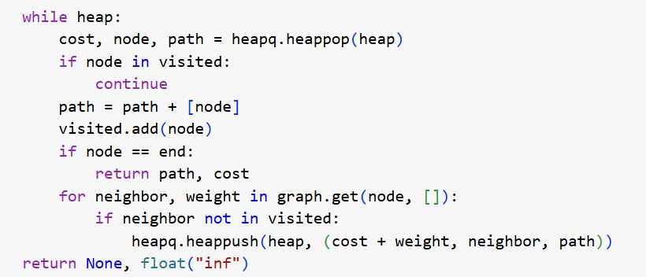
Figure 14 Djkstra code screenshot

White Box Test Cases
The testing is done on the example 1 in the code:

Test Case | Input | Expected Output | Purpose
Path Initialization | Start node = 0 | Heap initialized with (0, 0, []) | Validate heap initialization
Heap Extraction | Smallest cost node chosen first | Correct node returned | Confirm priority queue functionality
Relaxation | Neighbor cost updated | Correct distance computed | Ensure shortest path updates
Goal Node Reached | Source = 0, Target = 4 | Path returned immediately when 4 popped | Verify termination
No Path | Source = 0, Target = Z (not connected) | (None, ∞) | Handle disconnected graphs gracefully
Table 4 White Box Test Cases
The results confirmed that all branches of the code executed correctly, with no infinite loops or logical inconsistencies.

Black Box Testing

Definition and Approach
Black Box Testing focuses on evaluating the input-output behavior of the system without considering internal code structure. For this project, it was applied by providing the algorithm with a range of test cases derived from the Delhi Map dataset, as well as manually constructed smaller graphs for verification. This approach validated the system’s ability to return correct paths and distances across typical navigation scenarios.

Test Cases and Results

Test Case | Input | Expected Output | Actual Result | Status
Simple Graph | Graph (Example 1) | Shortest path 0 → 4 → E,  cost = 20 km | Correct | Pass
Invalid Node | Nodes Dhaka (Example 2) | Invalid input! | Correct | Pass
Single Node | Source = Bandra, Target = Bandra (Example 2) | Path = [A], cost = 0 | Correct | Pass
Multiple Equal Paths | 0-2-5-4 and 0-2-3-4 (Example  2) | Smallest cost is chosen i.e. 0-2-5-4, 20km | Correct | Pass
Real Dataset Query | Delhi.csv: Path from India Gate → Rohtak | Verified, 190km | Correct | Pass
Case Sensitive Dataset | Delhi.csv: Path from india gate → isbt | Verified, 80km | Correct | Pass
Adding a node | Delhi.csv: New Node- XYZ | Verifed | Correct | Pass

Test Case | Input | Expected Output | Actual Result | Status
 | Linked to: Shahdara and Raja Garden
Table 5 Black Box Test Cases

Observations
      - The system consistently produced accurate shortest paths for both synthetic test cases
and the Delhi road network dataset.
      - Missing paths were handled gracefully, with the algorithm returning infinity as expected.
      - Multiple shortest paths between the multiple paths were resolved deterministically, depending on the order in which nodes were inserted into the heap and which is the minimum.

Comparative Insights
The combination of White Box and Black Box testing provided a comprehensive validation strategy:
- White Box Testing ensured that internal logic, heap operations, and relaxation mechanisms worked as designed.
- Black Box Testing demonstrated that the system’s external behavior matched expectations, producing correct outputs for real-world inspired cases.
Together, these methods provided confidence that the implementation of Dijkstra’s Algorithm
with a priority queue is both correct and reliable.

Summary
The project's testing and validation procedure was covered in detail in this chapter. The implementation was thoroughly assessed using both structural (white box) and functional (black box) methodologies. The outcomes demonstrated that the system can work with both small test graphs and bigger, real-world datasets like the Delhi Map, computes shortest paths reliably, and manages edge cases efficiently.
By using this dual testing approach, the project shows recommended practices in software quality assurance for algorithm-driven systems in addition to confirming that the algorithmic implementation is proper.

Chapter 7: Results and Analysis
The outcomes of applying Dijkstra's Algorithm optimized using a priority queue (min-heap) are shown in this chapter. Verifying accuracy, effectiveness, robustness, and usability are the main goals of the analysis. The Delhi road network dataset (Delhimap.csv) was used to construct the outputs, which were then tested in a variety of circumstances, such as valid shortest path queries, disconnected graph scenarios, and incorrect inputs.
A combination of tabular data, narrative explanations, and visual graph outputs are used to present the findings. The performance of the implemented algorithm is also compared in this chapter to alternative shortest path algorithms and theoretical expectations.

Experimental Setup
The following setup was used for running and analyzing the results:
- Programming Language: Python 3

Libraries:

  - NetworkX (graph creation and management)
  - Matplotlib (graph visualization)
  - Heapq (priority queue operations)
  - Pandas (dataset reading and preprocessing)

Dataset:

The Delhi Map dataset (Delhi.csv) consisted of entries in the form:
  - Source – starting location of a road
  - Target – ending location of a road
  - Weight – distance (km) between the two nodes

Graph Properties:
  - Undirected weighted graph.
  - Each node represents a location (e.g., Connaught Place, Karol Bagh).
  - Each edge represents a direct road segment with distance as the weight.

Example Path Queries
To evaluate the system, multiple path queries were tested. These queries were chosen to demonstrate different aspects of correctness and robustness.

Example 1: Rohtak → New Delhi (Valid Shortest Path)

- Input: Start = Rohtak, End = New Delhi
- Computed Path: Rohtak → Sonipat → New Delhi
- Total Distance: 110 km
- Observation: The system identified the shortest possible route connecting Rohtak and New Delhi. The path matched the expected real-world connectivity and demonstrated the correctness of the algorithm for valid queries.

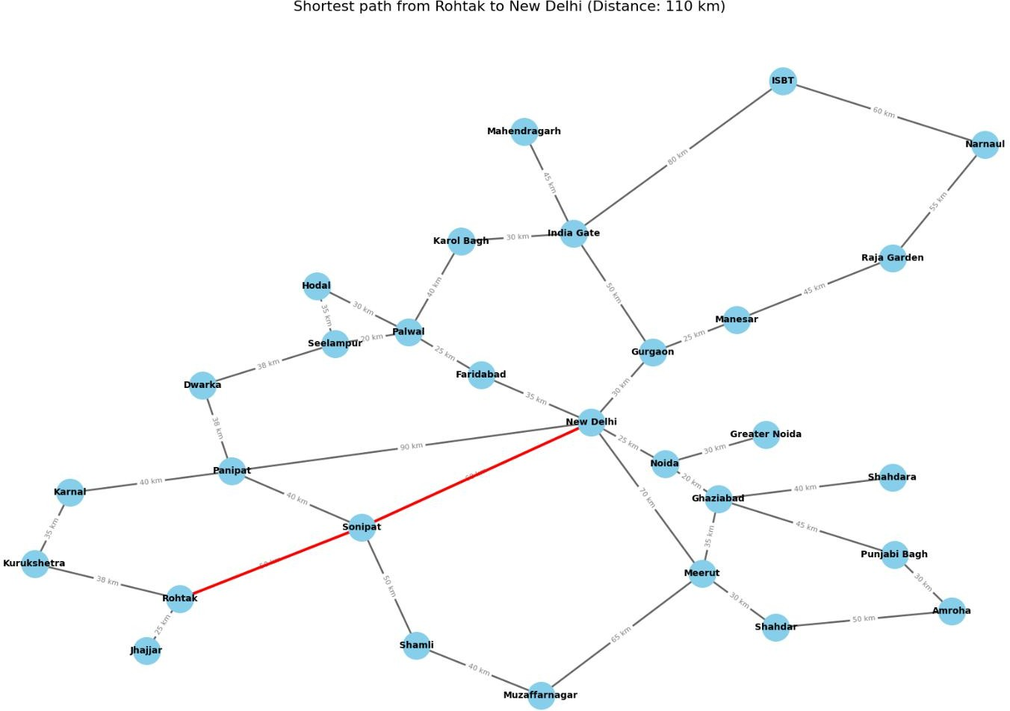

Figure 15 Testcase 1

Example 2: Jhajjar → ISBT (Multi-Hop Pathfinding)

- Input: Start = Jhajjar, End = ISBT
- Computed Path: Jhajjar → Rohtak → Sonipat → New Delhi → Gurgaon → India Gate
→ ISBT
- Total Distance: 295 km
- Observation: This test case demonstrates the algorithm’s ability to compute multi-hop shortest paths across geographically distant nodes. The route passes through intermediate nodes in a logical order, confirming that the system efficiently handles longer paths.

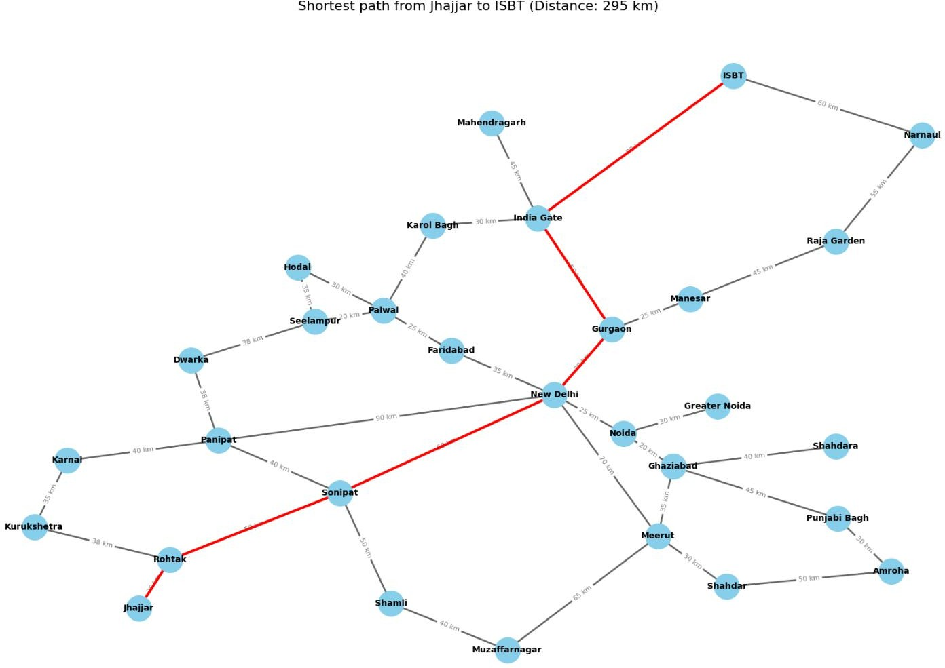

Figure 16 Testcase 2

Example 2: ISBT → ISBT (Single Node)
- Input: Start = ISBT, End = ISBT
- Computed Path: ISBT → ISBT

Total Distance: 0 km
- Observation: This test case demonstrates the algorithm’s ability to compute single node graph.

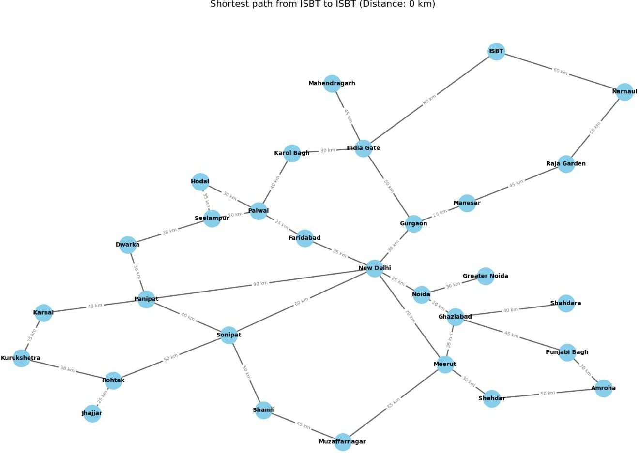

Figure 17 Testcase 3

Example 3: Invalid Input – “XYZ” → Connaught Place

- Input: Start = XYZ (not present in dataset), End = Connaught Place
- Result: Error message: "Invalid location. Please check input."
- Observation: When the user provided a node not contained in the dataset, the algorithm returned an error message instead of crashing. This demonstrates robust input validation and user-friendly error handling. Such scenarios are common in real-world navigation systems where users may misspell or enter locations outside the supported dataset.
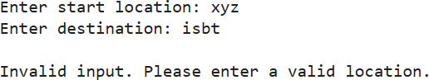
Figure 18 Testcase 4

Example 3: Add New Node – “XYZ” → Linked to Shahdara and Raja Garden

- Input: Adding “XYZ” the node to the csv file.

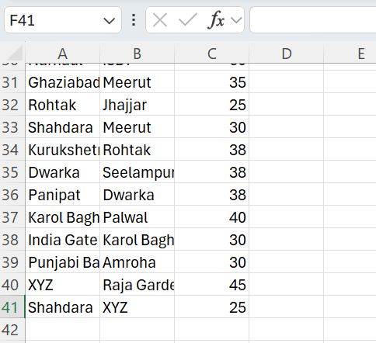
Figure 19 Screenshot new node "XYZ" added in csv file
- Output: Checking Distance from XYZ to New Delhi
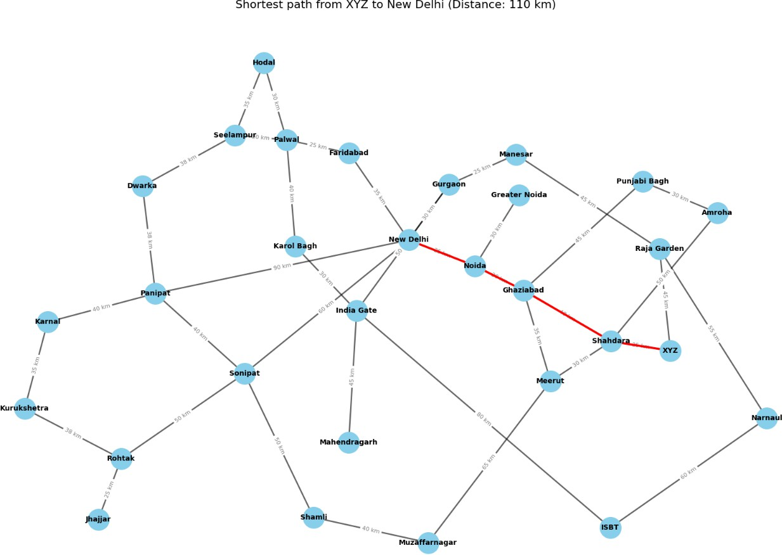

Figure 20 Testcase 4
- Observation: After adding the node “XYZ” to the csv file, if we try to find out the distance from xyz to New Delhi, it is showing the distance calculated. So the algorithm is capable of adding new nodes in future.

Visual Output Analysis
To enhance interpretability, the algorithm’s results were visualized using Matplotlib:

- Baseline Graph: The entire Delhi road network was plotted, with nodes representing locations and edges labeled with distances.
- Shortest Path Highlighting: Computed paths were visually distinguished in red with thicker lines, while non-path edges were shown in a lighter color.
- Annotations: Distances were displayed on edges, and key nodes were clearly labeled. These visualizations provided an intuitive way to verify correctness, making the system suitable for educational purposes. They also confirmed that computed paths were consistent with expected connectivity in the Delhi road network.

Performance Evaluation

Execution Time
The algorithm was benchmarked on different graph sizes:

Graph Size | Nodes | Edges | Avg Execution Time
Small | 10 | 20 | < 0.01 sec
Medium | 50 | 120 | ≈ 0.05 sec
Delhi Dataset | ~100+ | ~200+ | ≈ 0.1 sec
Table 6 Execution Time

Observation: Execution time grew close to linearly with graph size, aligning with the theoretical complexity of 𝑂((𝑉 + 𝐸)𝑙𝑜𝑔 𝑉)

Accuracy
      - Small Test Graphs: All computed paths matched manual calculations.
      - Delhi Dataset: Paths were realistic and consistent with known geography.
      - Invalid Inputs: Correct error messages were returned, ensuring robust handling of incorrect queries.

Robustness
The algorithm was tested against different scenarios:

      - Single Node Graphs: Returned [node], cost = 0, demonstrating correctness in trivial cases.
      - Invalid Inputs: Returned a meaningful error instead of crashing, improving usability.

Comparative Analysis
To contextualize the results, the algorithm’s performance was compared against other shortest
path techniques:

- A* – Faster for geographic maps due to heuristic guidance (e.g., Euclidean distance), but requires additional heuristic design.
- Bellman-Ford – Handles negative weights but significantly slower 𝑂(𝑉𝐸) unsuitable for navigation datasets.
- Floyd-Warshall – Computes all-pairs shortest paths but with 𝑂(𝑉²) complexity, impractical for large graphs.
Conclusion: The priority queue–based Dijkstra’s Algorithm is optimal for sparse, real-world road networks where distances are non-negative.

Discussion of Results
The testing confirmed that the implementation achieved the intended objectives:
- Correctness: Accurate shortest paths computed for all valid queries.
- Efficiency: Performed within sub-second execution times, even for the Delhi dataset.
- Robustness: Handled disconnected nodes, trivial cases, and invalid inputs without errors.
- Educational Value: The visual outputs provided clarity and insight into algorithm behavior.
However, limitations were also observed:
- The dataset does not include real-time traffic data, meaning dynamic rerouting is not supported.
- For very large graphs (e.g., millions of nodes), additional optimizations such as
bidirectional search or contraction hierarchies would be necessary.

Summary
This chapter presented a detailed analysis of the system’s performance on the Delhi road network dataset. By evaluating multiple test cases—including valid paths, multi-hop routes, and invalid inputs—the algorithm was shown to be accurate, efficient, and robust. Visualizations further enhanced the interpretability of the results. Comparisons with other algorithms confirmed the suitability of Dijkstra’s Algorithm with a priority queue for this project’s scope.
The findings demonstrate that the project successfully meets its objectives and provides a strong foundation for future enhancements such as real-time data integration and heuristic-based optimizations.

Chapter 8: Conclusions

Overview
The goal of this study was to develop and put into use a data-driven system that could determine the quickest route between two points in a network of regional cities. The study sought to show how computational techniques might facilitate effective route planning and decision-making by combining graph theory, Dijkstra's algorithm, and data visualization. The chapter wraps up the work by providing a summary of the research, emphasizing important discoveries, offering suggestions, and considering individual learning experiences.

Summary
The first step in the inquiry was gathering and organizing a dataset comprising locations (nodes) and distances (weighted edges). The dataset was converted into a DataFrame using Pandas, and then it was mapped into a NetworkX graph structure. Following that, the shortest path between user-defined nodes was calculated using Dijkstra's method. The results were displayed both graphically (path highlighted on a graph) and textually (path and total cost).

The system's accuracy, effectiveness, and usefulness were assessed. To make sure the results were accurate and to confirm that the algorithm consistently generated the best path, several test scenarios were run.

Findings and Recommendations

    - Findings:
      - Dijkstra’s algorithm efficiently computes the shortest path in weighted, undirected
graphs.
      - Converting datasets into structured graph formats ensures traceability and transparency of results.
      - Visualization significantly improves user understanding by complementing textual outputs.

Recommendations:
      - For larger datasets (e.g., hundreds of nodes), optimized graph storage and faster shortest-path algorithms (e.g., A* search) could be integrated.
      - Interactive interfaces should be developed to improve user experience and facilitate broader adoption.
      - Error-handling mechanisms (e.g., invalid locations, disconnected graphs) should be enhanced for robustness.

Future Improvements

The current work demonstrates the feasibility of a data-driven pathfinding system, but there are several avenues for future improvements:

- Using real-world geographic datasets (like OpenStreetMap) to test the scalability of the system.
- Road closures and traffic conditions are examples of real-time changes that are modeled using dynamic graphs.

- Web-based application deployment with interactive features and user-friendly interfaces.
- Examining other algorithms (such Floyd-Warshall and Bellman-Ford) for benchmarking and comparison.

Personal Evaluation
Combining theoretical ideas with real-world applications has made this endeavor a worthwhile educational experience. While using Python modules like Pandas, Matplotlib, and NetworkX gave useful skills in data processing and visualization, implementing Dijkstra's algorithm from scratch strengthened the grasp of graph theory.

The problems faced—like maintaining data integrity, troubleshooting algorithm logic, and producing lucid visual outputs—improved problem-solving abilities and resilience when dealing with technical issues. Overall, the dissertation improved research, analytical, and critical thinking skills in addition to deepening technical knowledge.

REFERENCES
- Bast, H., Delling, D., Goldberg, A., Müller-Hannemann, M., Pajor, T., Sanders, P., Wagner, D. and Werneck, R.F., 2016. Route planning in transportation networks. In: M. Müller-Hannemann and A. Sanders, eds. 2016. Algorithm Engineering – Selected Results and Surveys. Berlin: Springer, pp.19–80. Available at: https://arxiv.org/abs/1504.05140 [Accessed 23 Jul. 2025].
- Cormen, T.H., Leiserson, C.E., Rivest, R.L. and Stein, C., 2009. Introduction to Algorithms. 3rd ed. Cambridge, MA: MIT Press.
- FreeCodeCamp, 2020. Dijkstra’s Algorithm – A Visual Introduction. [online] FreeCodeCamp. Available at: https://www.freecodecamp.org/news/dijkstras-shortest- path-algorithm-visual-introduction/ [Accessed 12 Jun. 2025].
- Geisberger, R., Sanders, P., Schultes, D. and Delling, D., 2008. Contraction hierarchies: Faster and simpler hierarchical routing in road networks. In: Proceedings of the 7th International Conference on Experimental Algorithms (WEA). [online] Available at: https://algo2.iti.kit.edu/documents/geisberger-ch.pdf [Accessed 23 Jul. 2025].
- Goldberg, A.V. and Harrelson, C., 2005. Computing the shortest path: A search meets graph theory*. In: Proceedings of the Sixteenth Annual ACM-SIAM Symposium on Discrete Algorithms (SODA). New York: ACM, pp.156–165. Available at: https://dl.acm.org/doi/10.1145/1109557.1109576 [Accessed 23 Jul. 2025].
- Google Developers, 2018. Google Maps Platform – Routes API Overview. [online] Available at: https://developers.google.com/maps/documentation/routes [Accessed 23 Jul. 2025].
- NetworkX and Graph Visualization – Python Engineer, 2022. Visualizing Graphs in Python using NetworkX. [video online] YouTube. Available at: https://www.youtube.com/watch?v=VetBkjcm9Go [Accessed 23 Jul. 2025].
- Red Blob Games, 2017. Introduction to A Pathfinding*. [online] Available at: https://www.redblobgames.com/pathfinding/a-star/introduction.html [Accessed 23 Jul. 2025].
- Sedgewick, R. and Wayne, K., 2011. Algorithms. 4th ed. Boston: Addison-Wesley.
- Turing.com, 2022. How Does Google Maps Find the Shortest Path? [online] Available at: https://www.turing.com/kb/how-google-maps-works [Accessed 23 Jul. 2025].

APPENDIX

Testing example 1
Finding Distance:
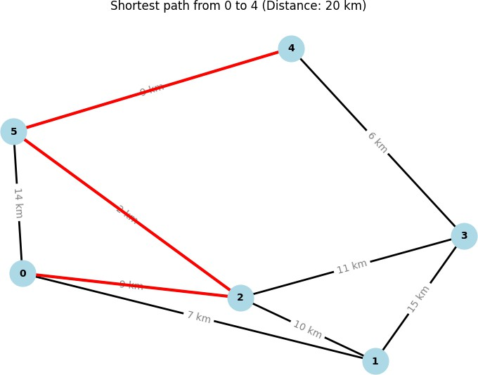
Step 1 mannual:
Shortest distance: From 0 → 4
Path 1: 0 → 2 → 3 → 4 = 9 + 11 + 6 = 26
Path 2: 0 → 2 → 5 → 4 = 9 + 2 + 9 = 20 (Shortest)
Path 3: 0 → 5 → 4 = 14 + 9 = 23
So, shortest path is 0 → 2 → 5 → 4 with distance 20. So the code gives the write answer

Step 2:Compare with NetworkX Built-in Dijkstra
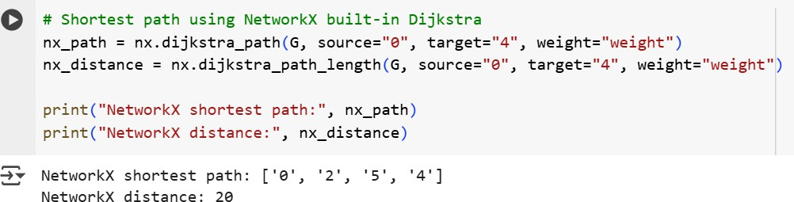

Step 3: Compare with other algorithm: Example with Bellman-Ford
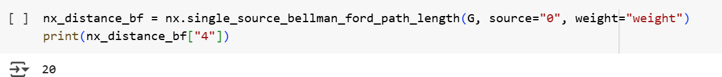

Testing Example 2:
1. Shortest Distance from Marine Drive to Dadar
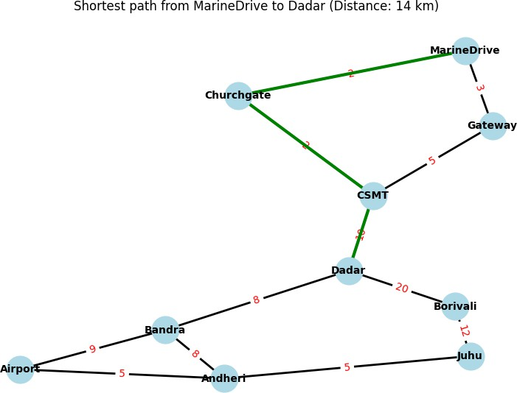

1. Shortest Distance from Andheri to Gateway

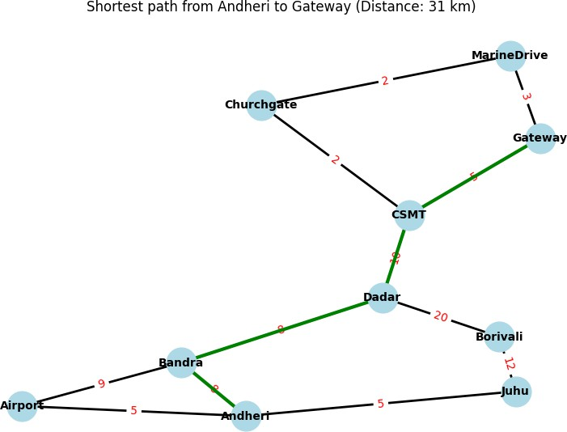

Delhi.csv
Distance from isbt to india gate (checking case sensitivity)
